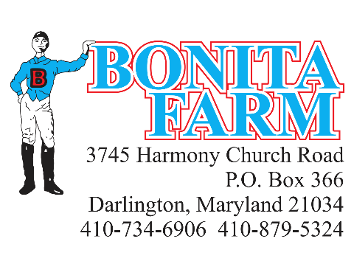
Email to hfbonitafarm@gmail.com or fax to 410-734-6789
A COMPLETED MARE INFORATION FORM MUST BE ON FILE WITH BONITA FARM PRIOR TO BEING BRED

Stallion: ______________________________
Mare’s Name: _________________________ Year Foaled: ________________ Color: ____________________
Sire: ___________________________ Dam: _________________________Dam Sire: ____________________
Mare’s Status:
_____In Foal _____Aborted _____ Barren _____ Not Bred _____Maiden _____ Foaled in 2021
Foaling Date: ________________________ Color/Sex of Foal: ____________________________
Breeding History:
2020 Stallion Bred To: _______________________________Last Bred Date: ____________________________
2019 Stallion Bred To: _______________________________ Foaling Date: _____________________________

Owner of Mare: ____________________________________
Address: __________________________________________
___________________________________________

Phone: ___________________________________________
Email: ____________________________________________
Additional Contact: _________________________________

Form completed by_________________________________ Date: _________________

Signature of owner/agent: __________________________________________________

